GlobalGadgets Sales Analysis
This project focuses on the analysis of Gadget sales dataset of unique product names across multiple product categories in different regions. The dataset captures a broad view of Product sales, Region that has most sales, the product that has most sales, Average sales, Total sales, and the total revenue generated entirely. This analysis builds an in-depth insight which helps in decision making by most companies to know their performances.

Data Cleaning and Preparation.
- I downloaded the dataset from the website and uploaded it to Microsoft Excel.
- In Excel, I changed the dataset into a table form to ensure efficient calculations using formulas.
- I proceeded to check whether the dataset has duplicates, ensuring all the columns are in their correct data type.
- I also check for blanks, after doing so, I ensure I sorted and filtered the dataset to avoid errors in making the appropriate analysis.
- I created a column to calculate the total revenue.
- For data summarization and analysis, the tool used was Pivot table
- After using Pivot table to draw summarization and analysis, I then used Pivot charts to visualize the tables.
- I then use PowerPoint to create a wireframe, which I transported into Excel to draw an appealing visualization for precise and quick decision making.

Pivot table and Pivot chart

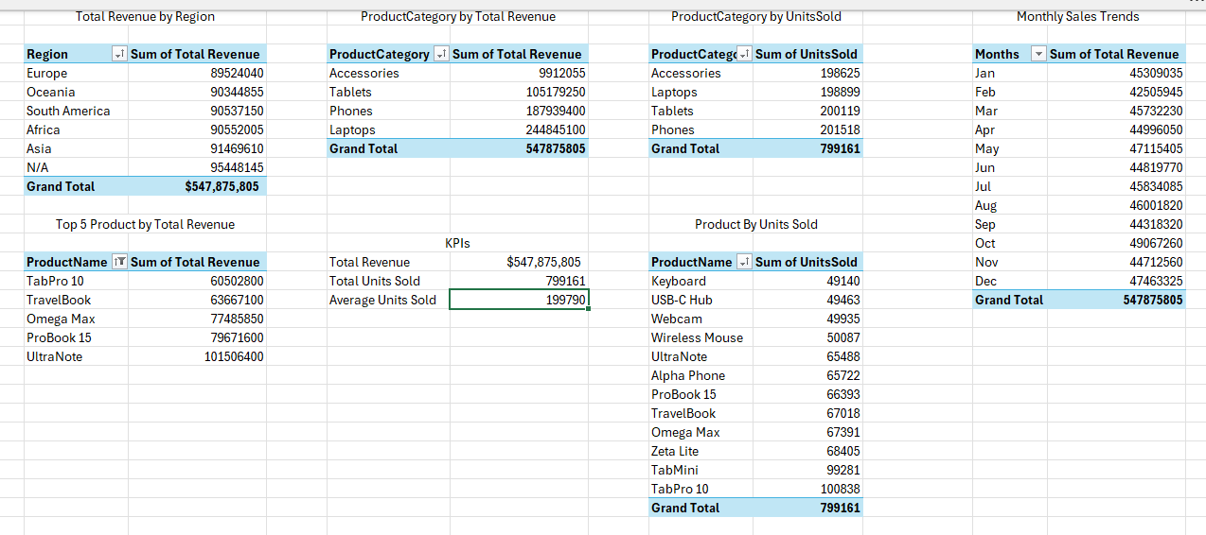

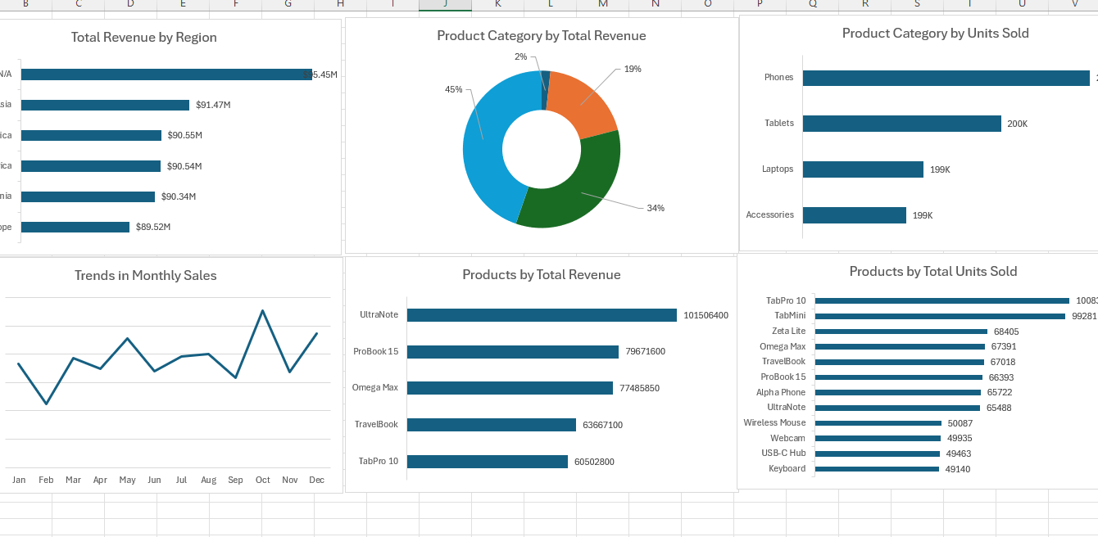

Dashboards
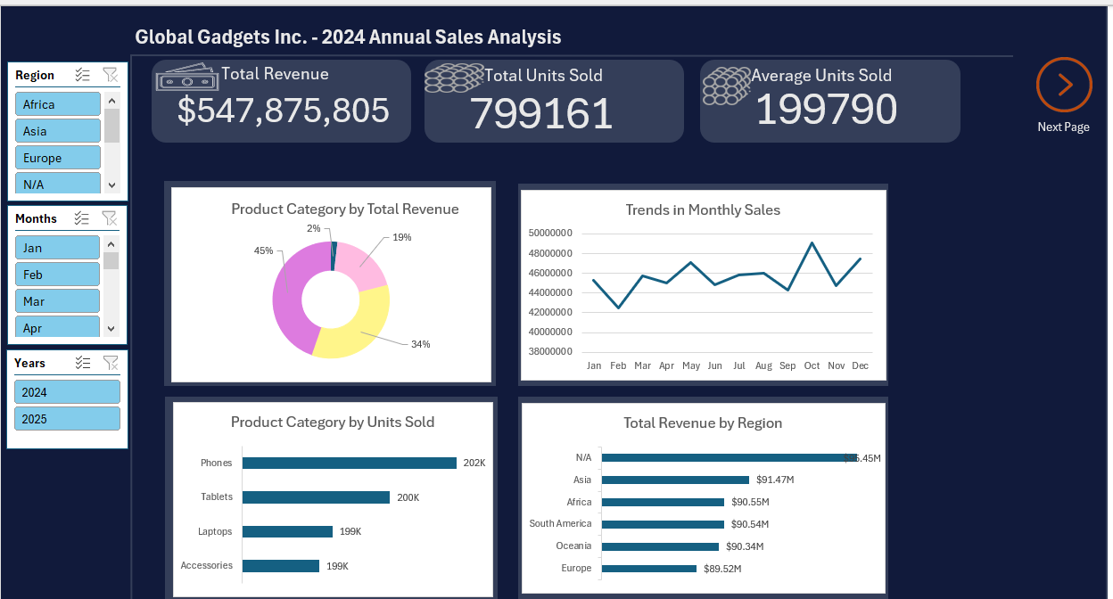
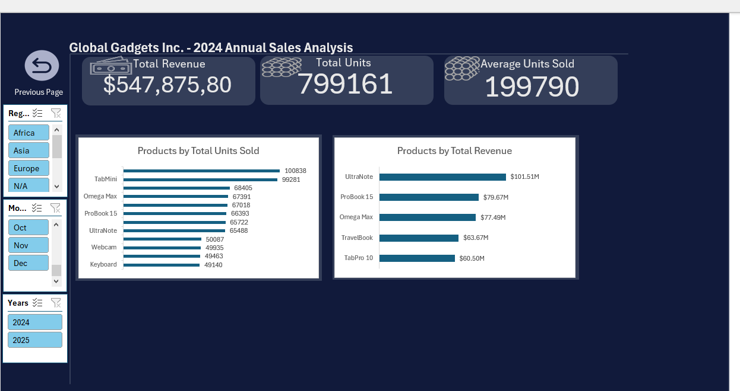

Insights:
- Laptops were the primary revenue driver, contributing roughly 45% ($244M) of total sales, despite Tablets being the highest volume category by units sold (400,000 units)

- October emerged as the peak revenue month ($49M), surpassing the traditional holiday peak in December ($47.4M), suggesting a strong reliance on Business-to-Business fiscal year end spending rather than just consumer holiday shopping.

- A significant data anomaly exists regarding location: The region labeled "N/A" outperformed all known regions (Asia, Africa, etc.), generating the highest total revenue of $95.4M.

- February recorded the lowest revenue of the year ($42.5M), reflecting a significant post-holiday slump, while May saw an unexpected spike ($47.1M), outperforming adjacent months likely due to mid-year corporate or educational purchasing cycles.

- Ultra Note was the single highest revenue-generating product ($101M), making it the most critical asset for the company's bottom line, whereas Accessories (like Keyboards and Mice) contributed negligible revenue despite decent sales volume.

- The third quarter (July–September) showed concerning stagnation, with monthly revenue flatlining between $44M and $46M, indicating a missed opportunity for "Back-to-School" growth strategies.

- Accessories and Tablets combined account for most operational logistics (shipping volume) but yield a disproportionately low share of the total profit margin compared to the high-ticket Laptop category.

RECOMMENDATIONS
1. Find the missing customers Since the "N/A" region is where we make the most money: We need to find out where those people live. We need to fix the error in the computer system immediately so we can start advertising to our best customers properly.
2. Stock more Laptops, fewer Tablets: We need to change how we manage our stock. Since Laptops make the real money, we must make sure we never run out of the Ultra Note. It is more important to have Laptops on the shelf than Tablets.
3. Introduce incentives like promotions or discounts to fix the flat sales in the summer: We should create special deals. Since we have too many cheap accessories, we can offer a deal like: "Buy a laptop, get a Mouse for free." This helps us sell the expensive computers during the slow months.
4. Bring customers back in February to stop sales from crashing in February: Since February was the month with lowest revenue due to it fallen in the range of months after Christmas, this happens as a result of people getting out of money after Christmas or the holiday month since they have spent their money, we can decide to run a promotion to our customers in the month of February to boost our sales or even lower the prices of our already stock products to ensure our customers buy our goods in the month of February.

